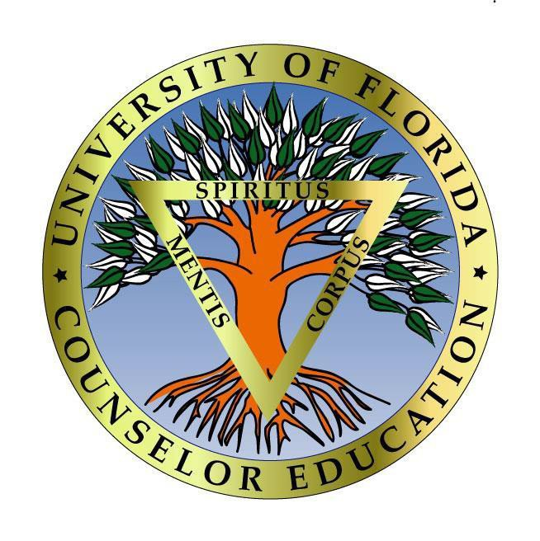
University of Florida
Counselor Education Program
2019-2020 Annual Report

The mission of the UF Counselor Education Program is to prepare exemplary counselor educators, marriage and family counselors, mental health counselors, school counselors, and program administrators who generate, use, and disseminate knowledge about human development and human relating to enrich the quality of life for all people, and who collaborate with others to solve critical personal, family, educational, social, and vocational problems in a diverse global community. Students and faculty are expected to behave in accord with the highest ethical and professional standards while engaged in accomplishing this mission.

The purpose of this annual report is to inform all stakeholders of the Counselor Education Program, including students, faculty, administration (school, college, and university), alumni, site hosts, employers of graduates, community partners, and the public about program evaluation results, program modifications based on these results, and other significant program changes.

Enrollment Data and Faculty Changes
The UF Counselor Education program admits new students once a year in the fall semester. The Program faculty reviewed and considered the admissions applications of 106 prospective master’s/educational specialist (Ed.S.) students and 32 doctoral students, and enrolled 37 master’s/Ed.S. and 8 doctoral students. Table 1 contains a summary of the number of prospective students that applied, were admitted, and enrolled.

Table 1: Number of Students that applied, were admitted, and enrolled during the 2019-2020 year

Program | Applied | Admitted | Enrolled
Master’s/Ed.S. Program Tracks
Mental Health (CMHC) | 72 | 31 | 22
Marriage and Family (MCFC) | 16 | 14 | 12
School (SC) | 18 | 13 | 3
Master/Ed.S. Total | 106 | 28 | 37
Doctoral Program
Ph.D. in Counseling and Counselor Education (CES) | 32 | 14 | 8

Number of Graduates, Program Completion, Certification/Licensure Exam Pass Rate, and Job Placement Rate
There were 38 Master’s/Ed.S. students and 7 doctoral students that graduated during the 2019-2020 academic year. The program completion rate was 100% for the master’s/Ed.S. program and 100% for the doctoral program. Graduates of the Program consistently pass the State of Florida licensure exam and the school counseling certification exam, with a reported overall rate of for the reporting period. Furthermore, the graduates reported job placement rate for the 2019-2020 year was 100% for the MH & School Master’s/Ed.S. program, 83% for the MFC program, and 100% for the doctoral program. Table 2 contains a summary of the number of graduates, program completion rate, certification/licensure exam pass rate, and job placement rate for the 2019-2020 academic year.

Table 2: Graduation, Certification/Licensure, and Job Placement Data
Program | Number of Students who Graduated | Completion Rate | Certification/ Licensure Exam Pass Rate | Job Placement Rate*
Master’s/Ed.S. Program Tracks
Mental Health (CMHC) | 23 | 100% | 85%* (16/19) | 100%  (n=12)
Marriage & Family (MCFC) | 11 | 100% | N/A | 83%  (n=6)
School (SC) | 10 | 100% | 100% | 100%  (n=6)
Master’s/Ed.S. Total | 38 | 100% | 93% | 97%
Doctoral Program
Ph.D. in Counseling and Counselor Education (CES) | 7 | 100% | N/A | 100%  (n=4)
Note: Mental health licensure exam pass rate reported for 2019, as the report is published by the calendar year, n=21. In addition, this is not a reflection of recent graduates, but anyone affiliated with the program that takes their licensing exam in the several years following graduation.
*Based on employment survey sent to graduates Fall 2020, 45% completion rate

Curricular Evaluation and Enhancement
In accordance with the 2016 CACREP standards, the UF Counselor Education Program collected data in alignment with their Comprehensive Assessment Plan to measure and evaluate key program components, student progress, and curriculum design.

Master’s/Ed.S.
Master’s/Ed.S. KPIs: In reviewing data for key performance indications (KPIs) for the 2019-2020 year, the majority of master’s/Ed.S. students scored at the accomplished or exceptional performance level for all KPIs. No master’s/Ed.S. students scored in the unsatisfactory performance level for any KPIs.

Master’s/Ed.S. Academic Performance and Professional Dispositions: New students are evaluated after their first semester in the program and support was provided where needed. All students are evaluated in the spring. In evaluating 106 current students in the Spring 2020, 95% were rated satisfactory or outstanding in all areas. There were 5 students who were rated as needs improvement in one to nine areas out of the fifteen competency domains. Students evaluated in the needs improvement and unsatisfactory categories met with their advisors to discuss plans to address these areas.

Master’s/Ed.S. Student Engagement: Students are required to complete a self-evaluation in the spring of every year that includes a report of their engagement in various areas throughout the year. Table 3 contains a summary of master’s/Ed.S. student self-reported engagement data.

Table 3: Master’s/Ed.S. Student Self-Reported Engagement
Area | Involved
Graduate Assistantship | 8 (21%)
Research Experience | 9 (21%)
Leadership and Advocacy Experience | 60 (24%)
Professional Development | 50 (19%)
Conference Presentation | 2 (5%)
Note: N = 42.

Master’s/Ed.S. Students’ Evaluation of Practicum and Internship Sites: Practicum and internship students are asked to evaluate the placement site and the practicum and internship experience at the end of the semester for each placement. The students identified strengths (e.g., providing feedback that identified strengths and areas for growth, experiential learning, offering a variety of experiences at sites to enhance knowledge and clinical skills), and areas for improvement (e.g., consistency among faculty & clinical site supervisors; more opportunities to work with families [marriage and family students]), with the majority of students rating their supervisors and their placement sites as positively affecting their education experience. The mean scores on these evaluations, which included a 4-point scale, ranged from 3.36-4.0.

Master’s/Ed.S. Site Supervisor Evaluation: Site supervisors evaluate the overall preparation of the students for clinical experiences and the experience with the program during the clinical experience process. Site supervisors identified some areas to further strengthen clinical experiences (e.g., professional dress; and Zoom check ins with supervisors). Site supervisors also acknowledged the high quality of the program, noting that UF counselor ed students are ‘high quality’.

Master’s/Ed.S. Exit Survey: Students complete an exit survey at the end of their program. For the 2019-2020 year, there were 35 master’s/Ed.S. students that completed the exit survey. Students identified program strengths (e.g., faculty relationships, the cohort model, experiential activities and opportunities to apply knowledge in courses through practicing skills; diverse practicum and internship sites), and areas for improvement (e.g., consistency of faculty, need for more/clearer focus on theory), with the majority of students reporting that they agreed or strongly agreed that they were prepared to work in the counseling field in all areas included on the survey.

Doctoral
Doctoral KPIs: In reviewing data for key performance indications (KPIs) for the 2019-2020 year, all doctoral students scored at the accomplished or exceptional performance level for all KPIs, with no students performing at the developing or unsatisfactory levels.

Doctoral Academic Performance and Professional Dispositions: New students are evaluated after their first semester in the program and support was provided where needed. All students are evaluated in the spring. In evaluating 25 current students in the Spring 2020, 24 (95.5%) were rated as satisfactory or outstanding in all areas. One was rated as needs improvement in one category, and met with their advisor/dissertation chair to discuss plans to address this area.

Doctoral Student Engagement: Students are required to complete a self-evaluation in the spring of every year that includes a report of their engagement in various areas throughout the year. Table 4 contains a summary of doctoral student self-reported engagement data.

Table 4: Doctoral Student Self-Reported Engagement
Area | Involved
Graduate Assistantship | 15 (100%)
Research Experience | 14 (87.5%)
Teaching Experience | 16 (94%)
Supervision Experience | 9 (56%)
Leadership and Advocacy Experience | 16 (94%)
Counseling and Consultation Experience | 9 (53%)
Professional Development | 12 (75%)
Conference Presentation | 10 (62.5%)
Note: N=20.

Doctoral Exit Survey: Students complete an exit survey at the end of their program. For the 2019-2020 year, there were two doctoral students that completed the survey. Of these students, both reported being satisfied or highly satisfied with all aspects of the program controlled by program faculty. Students identified areas for improvement (e.g., greater flexibility in internship), and program strengths (e.g., timeline, internship).

Constituent Surveys
In accordance with the 2016 CACREP standards, the UF Counselor Education Program used all updated constituent surveys, including surveys to Site Supervisors, Employers, and Alumni to inform program modifications that enhance the quality of our program. Alumni surveys are sent out every other spring semester, thus constituents will be re-surveyed this coming spring semester. Employer surveys will be sent out Spring 2022.

CACREP Self Study
CACREP accreditation for the four program areas expires in 2020. The Program submitted their CACREP self-study for re-accreditation under the 2016 standards in January 2019. After an initial review, CACREP invited the Program faculty to make minor revisions in an addendum, submitted in August 2019. The CACREP site team visit was scheduled for Fall 2019, then rescheduled for Spring 2020. Due to COVID19, it will now be held virtually in October 2020.

Program Changes and Modifications
In reviewing all program evaluation data, including aggregate data from the 2016 CACREP standard key performance indicator (KPI) assignments, enrollment data, and constituent surveys, the faculty made the following program modifications:

Implemented changes:
-Evaluated & selectively adjuncts, reviewed teaching evaluations to make hiring decisions
-Greater onboarding of adjuncts
-School counselor skills checklist created & sent to supervisors & students
-CSJ chapter initiated
-More frequently sent email & SM communications when social/cultural events occur that harm our CE community
-Community meetings focused on student support & diversity initiatives
-Provided diversity resources and training
-Zero credit option available for doctoral students to teach/serve as a teaching intern outside of Counselor Ed internship for greater opportunities
-Offering advanced substance abuse training through ASPIRE
-Updated and expanded new student on-boarding process
-Added slides to Open House & Orientation trainings highlighted commitments to diversity and social justice
-SJCC created and CO-PI by CE faculty
-Increased recruitment efforts around diverse applicants
-GRE requirement removed for Masters/EdS applicants
-Updated professional development trainings & offered remote access for site supervisors, scaffolded trainings per site supervisor development

Goals:
-Reduce adjuncts to improve continuity & careful selection of adjuncts (communication/timeliness of duties)
-Re-working final assessment for P&I to increase clarity
-Workshopping syllabi to address diversity gaps/de-colonizing the syllabus
-Greater integration of school counseling & MFC into core curriculum
-Encourage collaborations with faculty early in the program for doctoral research & writing
-Explore curriculum changes related to diversity development early in the program
-Explore & promote options for doctoral students to present locally
-Plan out classes in doctoral curriculum to highlight and review conference proposals/ presentations
-Organizing & labeling research teams as labs for greater visibility & understanding
-Explore application & interview process related to diversity and cultural humility
-Continue to send communications to students regarding diversity workshops and trainings

Other program changes included:
-One new clinical assistant professor, one new visiting assistant clinical professor, and one tenure-track professor joined the Program for the 2019-2020 academic year
-Conducted one successful faculty search for an MFC clinical professor
-One tenure-track professor left the program/university

