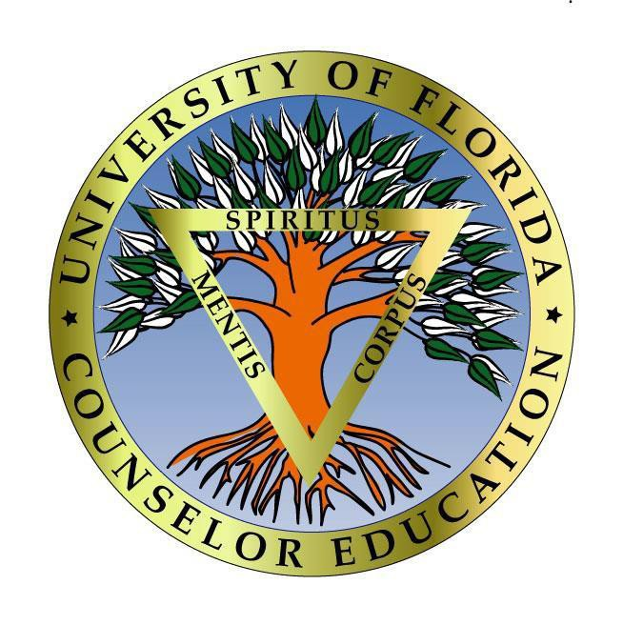
University of Florida
Counselor Education Program
2022-2023 Annual Report

The mission of the UF Counselor Education Program is to prepare exemplary counselor educators, marriage and family counselors, mental health counselors, school counselors, and program administrators who generate, use, and disseminate knowledge about human development and human relating to enrich the quality of life for all people, and who collaborate with others to solve critical personal, family, educational, social, and vocational problems in a diverse global community. Students and faculty are expected to behave in accord with the highest ethical and professional standards while engaged in accomplishing this mission.

The purpose of this annual report is to inform stakeholders of the Counselor Education Program, including students, faculty, administration (school, college, and university), alumni, site hosts, employers of graduates, community partners, and the public about program evaluation results, program modifications based on these results, and other significant program changes.

Enrollment Data and Faculty Changes
The UF Counselor Education program admits new students once a year in the fall semester. The Program faculty reviewed and considered the admissions applications of 190 prospective master’s/educational specialist (Ed.S.) students and 21 doctoral students and enrolled 31 master’s/Ed.S. and 3 doctoral students. Table 1 contains a summary of the number of prospective students that applied, were admitted, and enrolled.

Table 1: Number of Students that applied, were admitted, and enrolled during the 2022-2023 year

Program | Applied | Admitted | Enrolled
Master’s/Ed.S. Program Tracks
Mental Health (CMHC) | 31 | 15 | 7
Marriage and Family (MCFC) | 135 | 27 | 17
School (SC) | 24 | 11 | 7
Master/Ed.S. Total | 190 | 53 | 31
Doctoral Program
Ph.D. in Counseling and Counselor Education (CES) | 21 | 5 | 3

Number of Graduates, Program Completion, Certification/Licensure Exam Pass Rate, and Job Placement Rate
Thirty-five Master’s/Ed.S. students and 7 doctoral students that graduated during the 2022-2023 academic year. The program completion rate was 100% for the master’s/Ed.S. program and 99% for the doctoral program. Graduates of the Program consistently pass the State of Florida licensure exam and the school counseling certification exam, with a reported overall rate of for the reporting period. Furthermore, the graduates reported job placement rate for the 2022-2023 year was 100% for the Master’s/Ed.S. program, and 100% for the doctoral program. Table 2 contains a summary of the number of graduates, program completion rate, certification/licensure exam pass rate, and job placement rate for the 2022-2023 academic year.

Table 2: Graduation, Certification/Licensure, and Job Placement Data
Program | Number of Students who Graduated | Completion Rate | Certification/ Licensure Exam Pass Rate | Job Placement Rate*
Master’s/Ed.S. Program Tracks
Mental Health (CMHC) | 23 | 100% | 82% | 100%  (n=23)
Marriage & Family (MCFC) | 11 | 100% | 90% | 83%  (n=11)
School (SC) | 6 | 100% | 100% | 100%  (n=6)
Master’s/Ed.S. Total | 35 | 100% | -- | 97%
Doctoral Program
Ph.D. in Counseling and Counselor Education (CES) | 7 | 100% | N/A | 100%  (n=7)

Note: Mental health licensure exam pass rate reported for 2022, as the report is published by the calendar year. In addition, this is not a reflection of recent graduates, but anyone affiliated with the program that takes their licensing exam in the several years following graduation.

Curricular Evaluation and Enhancement
In accordance with the 2016 CACREP standards, the UF Counselor Education Program collected data in alignment with their Comprehensive Assessment Plan to measure and evaluate key program components, student progress, and curriculum design.

Master’s/Ed.S.
Master’s/Ed.S. KPIs: In reviewing data for key performance indications (KPIs) for the 2022-2023 year, the majority of master’s/Ed.S. students scored at the accomplished or exceptional performance level for all KPIs. No master’s/Ed.S. students consistently scored in the unsatisfactory performance level for any KPIs.

Master’s/Ed.S. Academic Performance and Professional Dispositions: New students are evaluated after their first semester in the program and support was provided where needed. All students are evaluated in the spring of 2023. In evaluating 106 current students in the Spring 2023, all were rated satisfactory or outstanding in all areas. Students who were evaluated as needing support met with their advisors to discuss plans to address these areas.

Master’s/Ed.S. Students’ Evaluation of Practicum and Internship Sites: Practicum and internship students are asked to evaluate the placement site and the practicum and internship experience at the end of the semester for each placement. The students identified strengths (e.g., providing feedback that identified strengths and areas for growth, experiential learning, offering a variety of experiences at sites to enhance knowledge and clinical skills), and areas for improvement (e.g., more opportunities to work with families [marriage and family students]), with the majority of students rating their supervisors and their placement sites as positively affecting their education experience. The mean scores on these evaluations, which included a 4-point scale, ranged from 3.5-4.0. Most were 3.8 and above.

Master’s/Ed.S. Site Supervisor Evaluation: Site supervisors evaluate the overall preparation of the students for clinical experiences and the experience with the program during the clinical experience process. Site supervisors identified some areas to further strengthen clinical experiences (e.g., timely communication with students, instruction on assessment tool) and student preparation (e.g., lethality assessments, DCF referral). Site supervisors also acknowledged the high quality of the program, noting that UF counselor ed students are ‘high quality.’

Master’s/Ed.S. Student Engagement

Program provided travel grant to 9 students as a means of providing financial support for professional development. The capstone assignment details conference participation and is documented in the Canvas assignment portal for each graduating student.

Master’s/Ed.S. Exit Survey: Students complete an exit survey at the end of their program. For the 2022-2023 year, there were 31 master’s/Ed.S. students that completed the exit survey. Students identified program strengths (e.g., connection with faculty, practical application in courses, group supervision, internship sites), and areas for improvement (e.g., consistency of faculty, more continuity across faculty, communication and transparency especially with faculty turnover and the pandemic, and preparing for post-graduate life), with many students reporting that they agreed or strongly agreed that they were prepared to work in the counseling field in the areas included on the survey.

Doctoral
Doctoral KPIs: In reviewing data for key performance indications (KPIs) for the 2022-2023 year, all doctoral students scored at the accomplished or exceptional performance level for all KPIs, with no students performing at the developing or unsatisfactory levels.

Doctoral Academic Performance and Professional Dispositions: New students are evaluated after their first semester in the program and support was provided where needed. All students are evaluated in the spring. In evaluating current students in the Spring 2023, most were rated as satisfactory or outstanding in all areas. One was rated as needs improvement in one category and met with their advisor/dissertation chair to discuss plans to address this area. All doctoral students in their second year who took the written qualifying exam passed.

Doctoral Student Engagement: Students are required to complete a self-evaluation in the
spring of every year that includes a report of their engagement in various areas throughout the
year. Documentation of doctoral student engagement is documented in their portfolios and evaluated by their doctoral committee members at the admission to candidacy meeting.

Doctoral Exit Survey: Students complete an exit survey at the end of their program. For the 2019-2020 year, there were two doctoral students that completed the survey. Of these students, both reported being satisfied or highly satisfied with all aspects of the program controlled by program faculty. Students identified areas for improvement (e.g., greater flexibility in internship), and program strengths (e.g., timeline, internship).

Constituent Surveys
In accordance with the 2016 CACREP standards, the UF Counselor Education Program used all updated constituent surveys, including surveys to Site Supervisors, Employers, and Alumni to inform program modifications that enhance the quality of our program. Alumni surveys are sent out every other spring semester, thus constituents will be re-surveyed this coming spring semester. Employer surveys will be sent out Spring 2024.

CACREP Self Study
CACREP accreditation for the four program areas was fully approved in 2022.

Program Changes and Modifications

In reviewing all program evaluation data, including aggregate data from the 2016 CACREP standard key performance indicator (KPI) assignments, enrollment data, and constituent surveys, the faculty made the following program modifications:

Implemented changes:

With an influx of new faculty, courses have been updated to reflect current trends in the counseling field. The program curriculum is stronger due to better alignment of courses with current trends in the field to improve course delivery, course content, and faculty instruction to meet the KPI standards.

Program faculty thoroughly reviewed student outcome data in a faculty meeting and discussed other initiatives for the year. Student outcomes remain strong, with 100% of students successfully completing their degree program at or above a satisfactory threshold of knowledge and competency. Site supervisors, recent graduates, and other community stakeholders noted areas for improvement, especially to improve career and job placement and networking with alumni. Our current evidence suggests students seem well prepared and competent for the next stage of their career, as evidenced by their electronic portfolio (documents their progress in the program). Program faculty continue to work to create scholarship and training opportunities for entry-level and doctoral students and created opportunities across coursework for students to develop as counseling researchers. In addition, this year, faculty added an additional training grant that offers students specialized training opportunities.

In our entry-level program, faculty continue to offer opportunities for students to develop a strong professional identity and sense of career prior to graduation. Advising and group trainings (e.g., post-graduation certification and licensure, career explorations, resume-building, etc.) seem to assist students in these areas, based on student feedback and placement data. We are able to explore areas of dissatisfaction as well in formulating new program activities to plan career preparation activities for the next academic year.

Goals:

The program faculty continues to transition roles and responsibilities (and to be over-tasked) due to faculty attrition. A main area for growth again this upcoming year is in maintaining and consolidating our current program leadership infrastructure and hiring new faculty. This ongoing transitional time means we continue to identify our core faculty strengths, as well as what each faculty member needs to develop and succeed within their assigned duties. Program faculty also remain committed to improving the program curriculum in key areas, including career placement and networking. Our goal for the 2023-2024 school year is to revitalize the doctoral program and admit a small cohort and highly qualified doctoral cohort for next year.

Student feedback from the exit surveys indicates several areas of focus that span the entry-level program areas. Many of these areas were impacted by the pandemic conditions that the December 2023 graduating students went through. Students indicated the following goals for program improvement.
- Increase transparency regarding P&I expectations from first semester
- Improve diversity among faculty
- Improve communication with faculty amid programmatic changes
- Lack of training in advanced family clinic due to the pandemic
- Hire school counseling faculty
- Improve post-graduation preparation

Other program changes included:

We lost more faculty this year, but the remaining faculty continue to pursue meaningful research projects and grant work, involving doctoral and master’s students in this work. The program faculty added one training grant this year to enhance training opportunities. Students are invited to participate in two training partnerships offered by federally funded grants. We are rebuilding faculty efforts at ongoing research team opportunities. Hiring initiatives are underway.

CACREP Vital Statistics 2022-2023
University of Florida Counselor Education Program

 | Number of Applicants | Number of Students Admitted | Number of Students Enrolled | Number of Students Graduated | Completion Rate | Certification/Licensure Exam Pass Rate | Job Placement Rate
Master’s/ Ed.S.
Marriage & Family | 31 | 15 | 7 | 6 | 100% | 90% | 100%
Mental Health | 135 | 27 | 17 | 23 | 100% | 82% | 100%
School | 24 | 11 | 7 | 6 | 100% | 100% | 100%
Total | 190 | 53 | 31 | 35 | 100% | 90% | 100%
Doctoral Program
Counseling and Counselor Education | 21 | 5 | 3 | 7 | 99% | N/A | 100%

