Method 1: Finding UFirst Current and Pending with Simple Search

- Go to grants.research.ufl.edu
- Log into UFIRST
- At the top of the screen, select Proposals then Filter by PI Last and enter Name
- This will give a list of the PI’s Proposals with pertinent info such as Proposal #; Short Title; State (status) and Sponsor.
- Click on the proposal(s) you want to include
- Select the “Key Personnel” tab to look at your committed person months for each period of the project

Method 2: Finding Current and Pending with UFirst Advanced Search

- Log into UFirst
- Select Proposals from the top bar

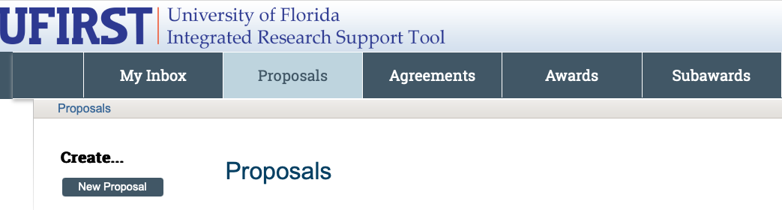

- Make sure you are on the “All Proposals” tab

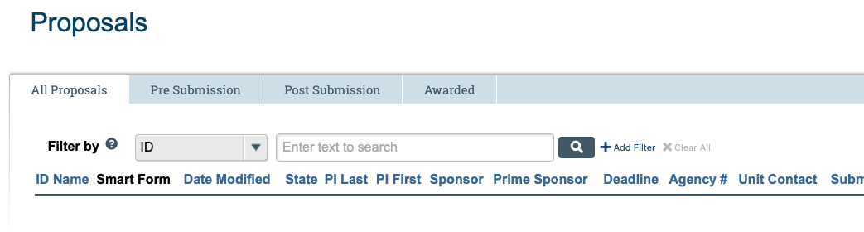

- Change the filter to PI Last and type in the appropriate last name

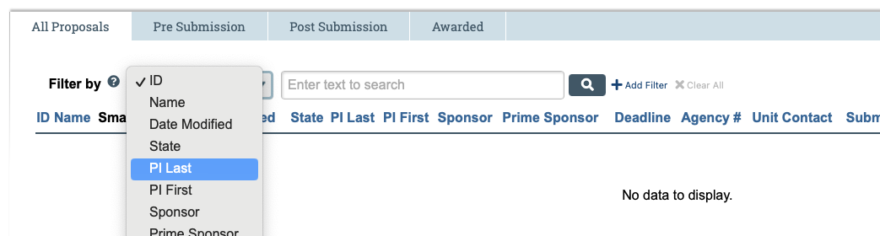

- Click add filter

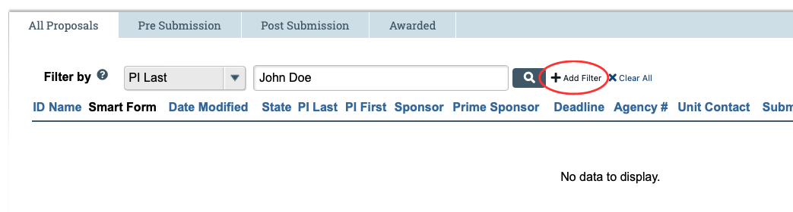

- Under “Filter by” choose “State”

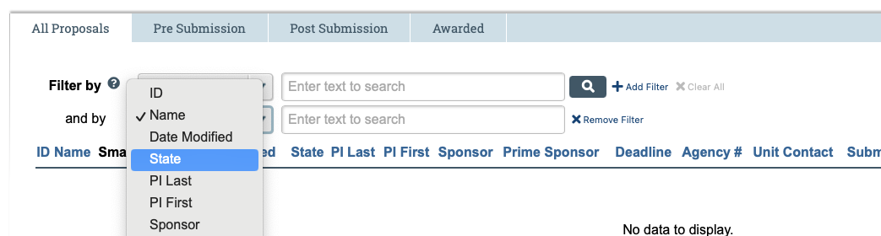

To Find Pending Awards
- Type “Pending Sponsor Review” into State search bar and click enter

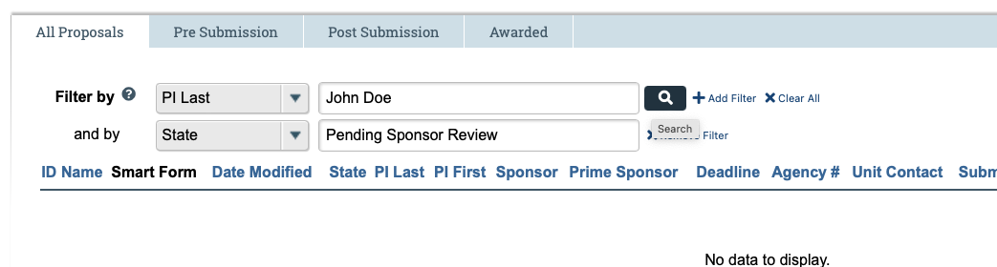

- Type “Draft” into State bar and click enter to get a list of proposals that have not yet been submitted

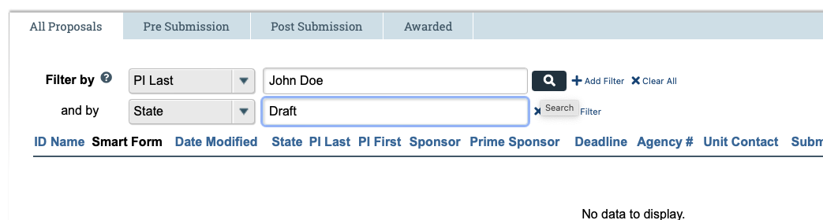

To Find Awards
- Type “Awarded” into State search bar and click enter

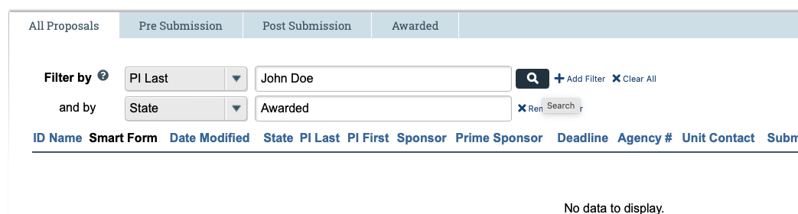

Updated: August 22, 2024

