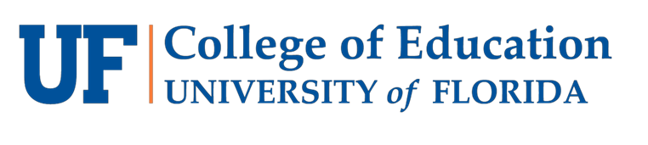
Diversity & Inclusion Committee
  - End of the Year Report, 2019-2020

Committee Members
HDOSE: Cliff Haynes (Chair), Hannah Bayne
STL: Kristen Apraiz, Gage Jeter (FPC Rep)
SESPECS: Kristi Cheyney-Collante, Lindsey Chapman
Dean’s Office: Nancy Waldron, Maria Leite

Mission statement (from FPC website):
The University of Florida Council on Diversity stated: “As the University of Florida harmonizes efforts to become one of the top public research institutions, a commitment to diversity is clearly illustrated in the University Work Plan to improve student and faculty diversity.” President Bernie Machen also stated: “Diversifying the faculty is a goal UF must achieve to maintain the vitality of the faculty and student body.” Following these two statements, the Diversity and Inclusion Committee of the College of Education has a commitment to not only improve student and faculty diversity but to have this diversity illustrated in the curriculum and service of the programs, degrees, and certificates produced in the College of Education. Further, we are also committed to the cultural competence of all members of the College of Education community.

Constitutional Responsibilities:
“This committee will consist of two people from each school as well as a voting representative of the Council. This committee shall make recommendations regarding policies and matters related to diversity within the College of Education.”

Meeting Dates
- September 24, 2019
- October 29, 2019
- November 21, 2019
- January 31, 2020
- March 20, 2020 (event planned but cancelled due to COVID-19)

Highlights/Actions Taken
- Held Ibram Kendi Pre-Event Discussion on November 21
- With education head librarian Rachael Elrod, requested e-book copy of Ibram Kendi’s How to Be an Antiracist and requested hard copies his books, including How to Be an Antiracist, Stamped from the Beginning, and The Black Campus Movement to be available in the Education Library.
- Cosponsored the "Looking Back and Moving Forward: African American Studies at the University of Florida Turns 50," symposium on February 20, 2020.
- Promoted the inaugural COE Diversity and Inclusion Award. Decided among three highly qualified applicants. Noted changes for next year’s award, including
  - Change the CV to match other awards and make it an abbreviated CV of 2 pages.
  - Bold the 500 words on the narrative.
  - Make a space on the form for the applicant to mark the primary area of impact
  - Potentially add the word primarily to the statement about impact.
- Supported the Social Justice Summit and was planning a pre-summit article/book chapter read of Dr. Gloria Ladson-Billings work on March 20. Unfortunately, both were cancelled due to the COVID-19 pandemic.
- Discussed and clarified the role of the college diversity liaison (Dr. Maria Leite) with this committee as coordinating all communication about events occurring in COE or on-campus that are not specifically sponsored by COE faculty or the D&I Committee and serving as a common thread between various committees and ad hoc committees on topics of diversity and inclusion.

Recommendations for Next Year
- Revise the committee mission statement to remove the comment about President Machen and to incorporate Inclusion, Diversity, Equity, and Access (IDEA)
- If doing a common read, consider the following:
  - A book chapter or article instead of an entire book
  - Having the focus be on a topic of diversity and inclusion that is not specifically on race/ethnicity (as the last two book reads have been on this topic)
  - Insure that there are action items/takeaways for practice
- Potential idea for an activity is doing “monthly challenges” like inclusive syllabi reviews, accessibility checks on canvas, and the follow 5 Twitter challenge.

