College of Education
Faculty Policy Council Meeting & Spring Faculty Meeting
Minutes April 19, 2021; 2:00-4:00pm, via ZOOM

Attendance:
- Diana Joyce-Beaulieu (Chair), Angela Kohnen (Chair-Elect)
- HDOSE Reps: Lindsay Lynch, Chris Curran, Helena Mawdsley, Hope Scheuermann
SESPECS Reps: Cyndy Griffin, Tara Mathien, Kristi Cheyney-Collante, Alice Kaye Emery
- STL Reps: Gage Jeter, Shelley Warm, Julie Brown, Maya Israel
- Deans: Glenn Good (Dean), Tom Dana (Senior Associate Dean), Thomasenia Adams (Associate Dean), Nancy Waldron (Associate Dean).
Approval of the Agenda
Motion to approve - Shelly Warm 2:02, Maya Israel seconded motion with consensus of the group to follow

Approval of Last Meeting’s Minutes (3-15-21)
Motion to approve: Shelly Warm; seconded by Cyndy Griffin at 2:06 pm with consensus of the group

Welcome
New FPC Representatives beginning their 2-year terms:
- Chris Redding (HDOSE), Anne Seraphine (HDOSE) and Cathy Atria (HDOSE alternate);
- James McLeskey (SESPECS), Carla Schmidt (SESPECS), and Penny Cox (SESPECS alternate)
- Magdi Castaneda (STL), Mark Pacheco (STL), and Matt Schmidt (STL alternate); Julie Brown (FPC Chair-Elect)

Deans’ Presentations:
- Associate Dean Nancy Waldron
  - Thanks to you all for continued support to our COE students throughout the year and all the support and modeled flexibility you have provided
  - Spring graduation numbers are typical to prior years
    - Undergrad: curricula changes
      - Teacher prep- major redevelopment
      - 1st cohorts will start in Fall 2021
    - Education Sciences- end of 2nd year with many faculty members involved
    - Enrolled—500 undergrad majors overall this fall
    - Grad
      - College admin officers -Overall seeing consistent number of applications with some seeing increases
      - Increase in complete applications for masters, EDD, Specialists—yielding positive results
      - Doc- GRE consideration: report with start date of Fall 2022 depending on what programs decide
        - Recruitment and university system change pending
        - Large recruitment effort: $24 recruitment packages—23 have been accepted by recruits to start in the fall with only 1 left ($22-31,000 annually for 4 years, tuition and GatorGradCare)
      - Active search for a new Dean of grad school- likely will bring some changes (structures, polices, procedures)
    - 19 volunteers to serve as graduation marshals—thank you
      - Grad participation is as high as is usually is (usually is around ~70%)
      - If anyone is still interested in serving as a marshal, please contact Associate Dean, Nancy Waldron
- Associate Dean Thomasenia Adam
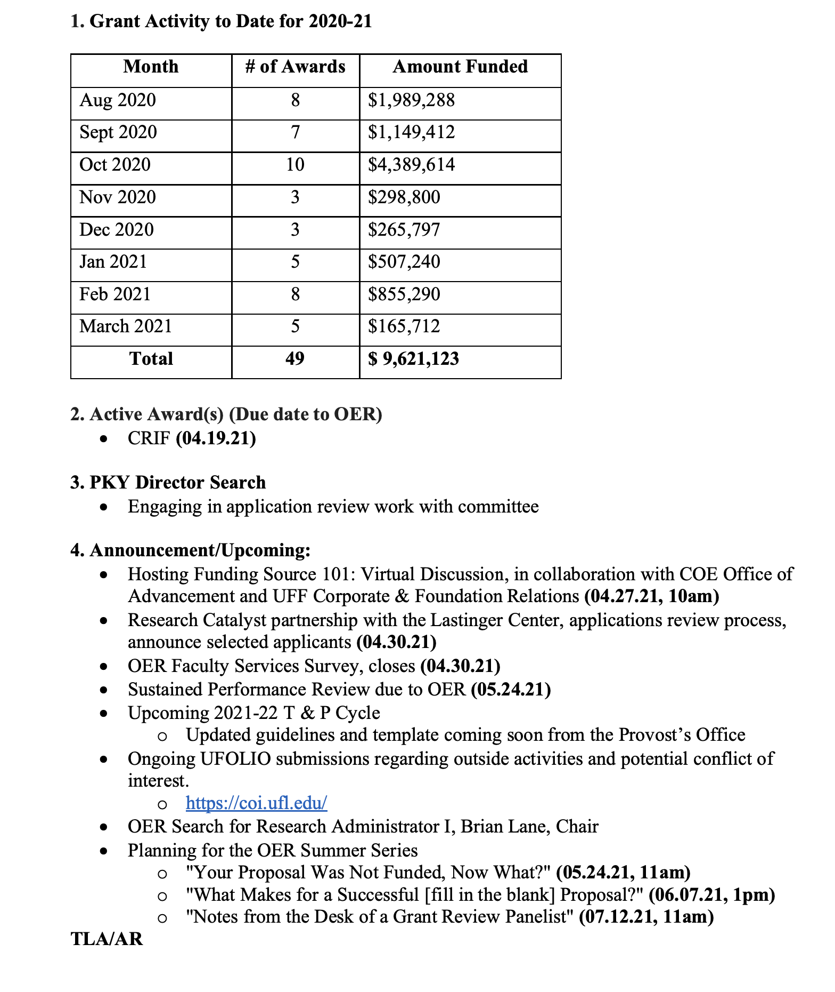
- Associate Dean Tom Dana
  - Assessment and Accreditation
    - Very busy year throughout the college for many faculty; thank you for all the time dedicated even in the midst of this year
    - CAPE
      - 3 Advanced programs with site visit, Formative feedback, May 10th site visit
  - Norman
    - Please make time to come to your office to make sure all is working appropriately in the next several weeks as we quickly approach Summer B and Fall’s full return to campus
  - IT
    - Emails—really important to pay attention to any IT alerts
    - Currently in an IT security audit
  - ETC
    - Social media, annual review
    - High interaction with online platforms at the moment
  - AI
    - Much more pronounced on campus, the anchors of AI in education
    - May 13th Townhall for AI discussions
  - This has been a Momentous year; humbled by all you have accomplished
- Dean Glenn Good
  - Pandemic
    - Alachua- 45% 1 shot, highest in Florida
  - Diversity
    - Working at multiple levels to address inclusion and equity with students, faculty and staff
  - Finances
    - 6% reduction last year
    - Still waiting for the release of this year’s budget
  - National reputation
    - All programs that are ranked are in the top 25
    - 13th in public COE—Nationally we are getting noticed
    - $30 million for state renovation funding
    - COE is only college named by UF in recent Public Relations piece - a testament to all your hard work this year

Senate Report:
- UF Senate Report – Chris Curran
  - Will not have the ability to ask students if they have been vaccinated due to legal concerns
    - ~60-75% have been
  - Board of Trustees meeting will discuss Baby Gator- need for more space
  - IDEA committee- diversity
    - Dr. Sarah Lynn
      - Guiding document with ideas regarding diversity and inclusion for the university
      - Encourage all to check this resource to see how can be integrated
  - May 6th next meeting

FPC Committee Annual Reports/Accomplishments for 2020-2021
- Budgetary Affairs – Cyndy Griffin FPC Rep (Anne Corrine Manley, Committee Chair)
  - The BAC drafted a Guiding Principles for Budget Decisions document that was sent to FPC, and adopted (in its final form) by the College of Education FPC on January 25, 2021. See BAC minutes from August 24, 2020 through December 3, 2020.
  - The BAC held eight meetings that included Dean’s updates on budgets with time allotted for feedback from faculty on any budget issues and on ideas for revenue generation. See all BAC minutes from the 2020-2021 year.
  - The BAC held many discussions about how faculty and Deans in the COE can best assist with equity issues in faculty salaries. The committee decided on two courses of action: (a) Recommend to Deans to regularly work with School Directors on merit issues related to equity, and (b) recommend to 2021-2022 BAC to develop a broad principles “flowchart” of faculty salary processes
- Diversity & Inclusion – Gage Jeter, FPC Rep & Committee Chair
  - Developed a resources guide that articulates committee’s role, purpose, and work within broader COE/UF initiatives
  - Created a mission statement submitted to the FPC and forwarded to faculty for broad input.
  - Revised course design and delivery (as evidenced by syllabi, Canvas course shells, peer/student evaluations, etc.) as a result of ongoing collaborative professional learning opportunities for instructors to critically examine and reviews, accessibility checks on canvas, and the follow 5 Twitter challenge.
  - Current/future courses intentionally revise the design and delivery of current/future courses
- College Curriculum – Angela Kohnen, FPC Rep & Committee Chair
  - Reviewed and approved modifications for 1 undergraduate major; approved 8 new Graduate Courses; Reviewed and approved 10 new Undergraduate Courses; Reviewed and approved 1 cross-listed course; Reviewed and approved 2 new concentrations; Reviewed and recycled 4 undergraduate courses; 2 new undergraduate minors; and 2 new graduate courses; Reviewed the list of courses that had been previously reviewed by CCC to determine status. Worked with original submitters to complete revisions and move proposals on to the appropriate university-level committee
  - Detailed information on specific course feedback and status are available through the CCC and Academic Approval System portals: https://education.ufl.edu/college-curriculum-committee/forms/
  - Investigated the status of courses with an equity, race, or diversity focus that had already been reviewed by CCC. The following courses received official course numbers this year: EDF 6636 (Theorizing Race and Racism in Educational Research) and EDF 6969 (Critical Race Theory in Educational Research), EDF 6820 (Education in Latin America)
  - Created additional resources for anti-racist curriculum, including a list of guiding questions for reviewers and submitters, and made these resources available on the CCC website
  - Worked with the curriculum sub-group of the CBSA to facilitate the approval of a graduate concentration focused on race and education and to begin the course approval process for a graduate certificate on anti-racism in education
- Faculty Affairs – Lindsay Lynch FPC Rep (Kristi Cheyney-Collanate Chair)
  - The Collective Bargaining Agreement was not approved until March 2021, so all goals related to CBA will continue into next year
  - Processes included evaluation through a social justice lens
  - CBA was ratified. Discussion on intellectual property, T&P annual review, and impact of COVID on teaching, research, and service, will continue into next year. This will evaluation of articles from a social justice lens.
  - Committee gathered information on how other R1 institutions account for labor of minoritized faculty in effort calculations. This work will continue into next year.
  - Committee drafted Recommendations to FPC on Impact of COVID 19 and Faculty Productivity. Recommendations were deferred in lieu of guidelines issued from Provost Office.
- Lectures, Seminars & Awards - Helena Mawdsley, FPC Rep & Committee Chair
  - In November 2020, a 2-day workshop, Equity, Empowerment, and Engagement: Collaborating with Predominately Black Community Organizations, presented by Dr. Janice Parker, Ph.D.;
  - In Feb 2021, Black Students in Graduate Education Programs: The Role of Connection, Support, and Intentionality presented by Dr. Sherri Proctor, Ph.D.
  - Reviewed 27 applications for 11 awards and selected recipients
- Long Range Planning – Angela Kohnen, FPC Rep (Nick Gage)
  - To understand our current level of diversity across the metrics of race/ethnicity, gender, disability, and nationality a survey was distributed and shared with faculty
  - Use this data to make targeted long-range goals for enhancing faculty diversity
  - Administered Dean’s annual evaluation
- Research Advisory - Alice Kay Emery, FPC Rep & Chair
  - Work with Diversity and Inclusion Committee to draft a statement about recruitment if faculty who can conduct research on equity issues. Diversity and Inclusion was not working on this however, the RAC reviewed job announcements for other colleges and universities and found often include a request for a diversity statement. The RAC is recommending the following for COE: University of Florida College of Education: Please provide a Diversity Statement. For the Diversity Statement, please describe and demonstrate how you will contribute to the College of Education’s culture of inclusion through your teaching, research, and service.
  - Goal: Revised language of CRIF for issues of equity – this was sent to Thomasina and was added to the CRIF priority statement. “Attention will be given to proposals that address issues of race and racism in black and brown communities.”
  - Goal: Wrote a statement/resource for faculty assisting them to think about the impact of their research on equity issues
- Technology & Distance Ed – Maya Israel, FPC Rep & Chair
- Reviewed online programs and US News rankings, discussed how the scores can be used for improvement.
- Sought out College sources for demographic data for review.
- Identified impact sources (e.g., GRE) for US News ratings
- Discussion guiding questions for Program Coordinators to apply to their data

FPC Action Items:
- Research Advisory – Alice Kay Emery, FPC Rep & Chair
  - Statement/resource for faculty assisting them to think about the impact of their research on issues of equity sent out for faculty review – no comments received. This is a resource for the FPC website, not a policy change suggestion. Does FPC wish to adopt as a resource?
    - Motion to accept as a resource. Julie Brown
    - 2nd Lindsey Lynch
    - Motion approved: 2:59pm, resource will be posted on FPC website
- Interest in adoption/adaptation of a diversity/Black anti-racism statement for COE to forward to the Dean for consideration (see sample statements document). Only comments received requested a new statement be drafted rather than adopting/adapting any of the sample statements provided. Does FPC wish to forward this to FAC or D/I?
  - Will move forward to next year’s 1st meeting
- Diversity & Inclusion – Gage Jeter, FPC Rep & Committee Chair
  - Updated mission/vision resource document sent to faculty for 2-week review period (see document). Comments were received and forwarded to the D/I committee for review.
  - Motion approved to be continued in the upcoming fall FPC meetings
- 2021-2022 FPC Leadership Transition

Announcements/Reminders:
- Please forward any recommendations or suggestions for FPC agenda items to Angela Kohnen akohnen@coe.ufl.edu
- Save-the-Date; FPC Meeting, August 30th, 2-4pm, Norman 2021 (old PK Library in Old Norman); Fall COE Faculty Meeting TBD
- 2021-2022 FPC New Members Orientation to follow this meeting.

Adjournment
Meeting Adjourned: 3:07pm with no objections

We appreciate your dedication and the progress you have facilitated in completing the work of the FPC this year. It has been an immense pleasure working with you each of you. Go Gators! Diana Joyce-Beaulieu & Angela Kohnen

