Join the College of Education’s Food Drive to benefit the Field and Fork Campus Food Program
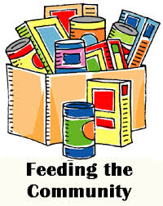
Field and Fork Mission: The Field and Fork Campus Food Program is a collaboration to create awareness about food insecurity and sustainable food practices. The program seeks to not only provide healthy food, but educate Gators on how to make balanced food choices.
http://fieldandfork.ufl.edu/

Deadline to donate to the COE’s Food Drive: Friday, April 8, 2016
How to Donate at the College of Education
Drop off items at the boxes located in:
- Dean’s Office - Rm. 140
- SESPECS - Rm. 1403
- SHDOSE - Rm. 1215
- STL – Rm. 2423
- Lastinger Center - Rm. G315
- Anita Zucker Center - Rm. 1345
- Student Services - Rm. G416
Examples of nonperishable food items we are collecting for the Field and Fork Program:
- Canned soup
- Pasta
- Pasta sauce
- Rice
- Oatmeal
- Cereal
- Macaroni & cheese
- Canned meats (chicken & tuna)
- Peanut butter & jelly
- Granola & breakfast bars
- Canned fruit
- Canned vegetables (excluding corn & green beans, fully stocked on these items)

For the Gator Good

“Creating awareness about food insecurity and sustainable food practices to support every Gator in times of need. The program provides healthy food and educate Gators on how to make balanced food choices” - Field and Fork
If you need more information, please contact the Dean’s Office at 273-4130.

